Chemistry
Unit 4
Area of Study 5 Test Answers:
Organic chemistry
Section 1: Multiple choice (12 marks)
Question 1
B Between water and:
• ethane, only dispersion forces operate
• ethanal, dispersion forces and dipole–dipole interactions operate
• ethanol, dispersion forces and hydrogen bonds operate
• ethanoic acid, dispersion forces, dipole–dipole and hydrogen bonds operate.
Question 2
C Primary alcohols and aldehydes can be oxidised to form carboxylic acids. Secondary alcohols such as III are oxidised to ketones.
Question 3
D The HBr will add across the double bond present in the middle of the molecule. The double bond breaks and, in this reaction, the Br bonds with C number 2 and the H bonds with C number 3.
Question 4
B A carboxylic acid, an amine, an amide, and an alcohol
Question 5
B The acid is as follows.
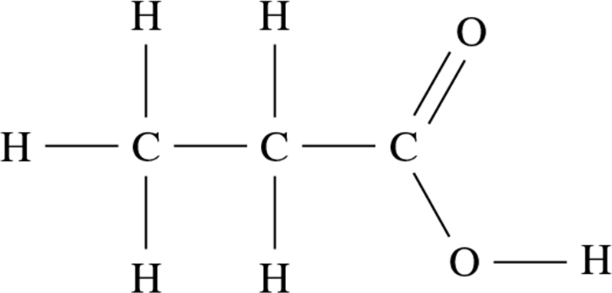
It has three carbon atoms, so it is propanoic acid. The alcohol is CH3CH2OH. It has two carbon atoms so it is ethanol.
Question 6
B I and III
End of section 1

Section 2: Short answer (14 marks)
* Indicates 1 mark
Question 7 (6 marks)
 | Reaction | Structural formula of the main organic product(s) | Name of the main organic product(s)
a | Excess acidified potassium dichromate is added to propan-2-ol | 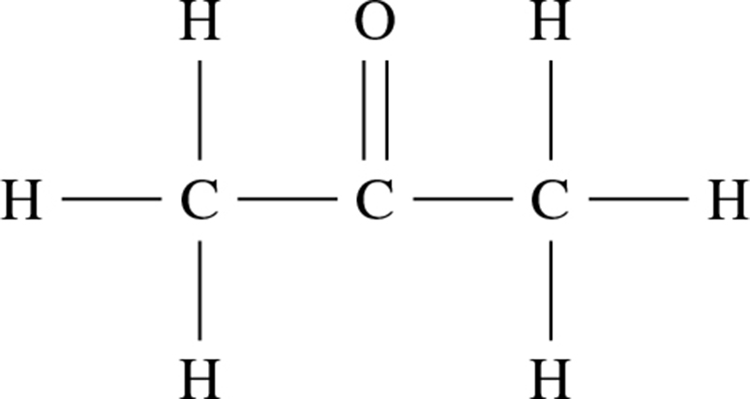 | propanone (2 marks)
b | Bromine water is added to cis-but-2-ene | 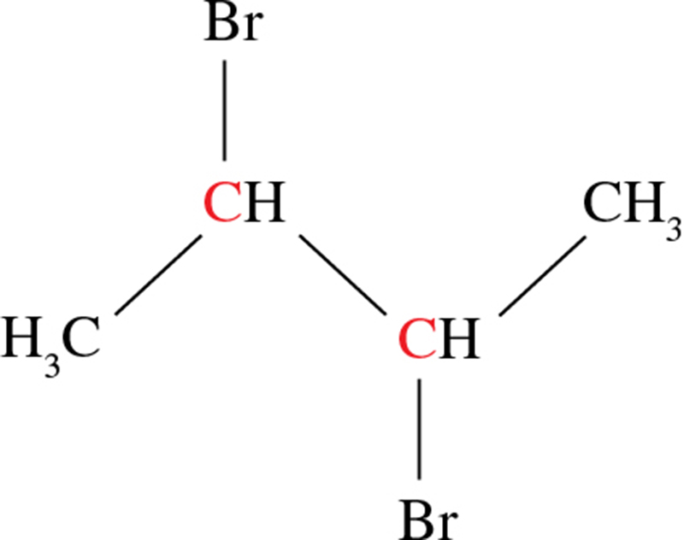 | 2,3-dibromobutane (2 marks)
c | Chloroethene forms an addition polymer. Draw a section of the polymer containing three monomer units  Note: no name is required. | 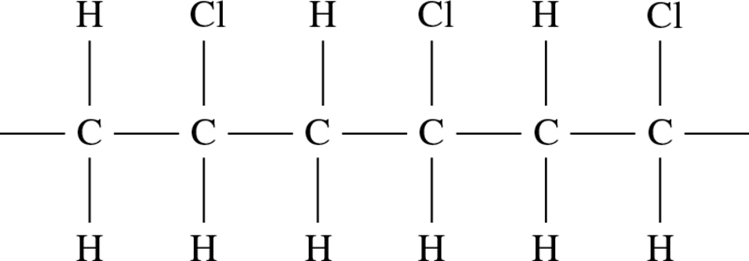 (2 marks)

Question 8 (6 marks)
a (2 marks)
Product A | Product B
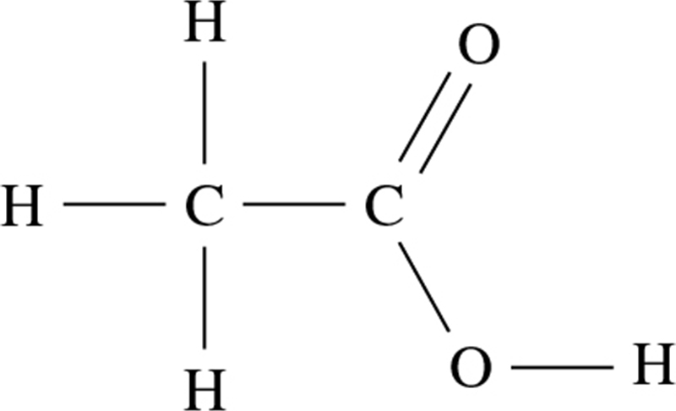 | 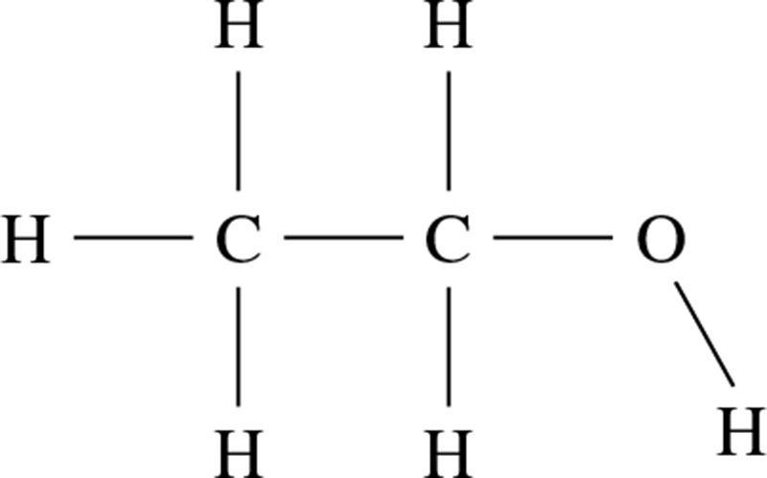
b Ethanol is able to form hydrogen bonds with water by virtue of the polar OH group, making it highly soluble in water. * Similarly, ethanoic acid is able to form hydrogen bonds with water through both the C=O and OH groups, rendering it highly soluble in water as well.*
Ethyl ethanoate is less soluble in water. Although it is still able to form hydrogen bonds with water molecules through its C=O group, it is a much larger molecule than both ethanol and ethanoic acid. The hydrocarbon chains on each end of the ester are only able to form dispersion forces with water molecules. This means that in order to dissolve, the large ester has to break a large number of hydrogen bonds between water molecules.* The energy released from the formation of the one ester–water hydrogen bond and dispersion forces is much less than the energy required to break all the water–water hydrogen bonds. For this reason, it is not energetically favourable and the ester is only slightly soluble.* (4 marks)
Question 9 (4 marks)
Addition: CH2CH2 + HBr → CH2BrCH3 (2 marks)
Substitution: CH3CH3 + Br2 → CH2BrCH3 + HBr (UV light/catalyst) (2 marks)
End of section 2

Section 3: Extended answer (22 marks)
* Indicates 1 mark
Question 10 (10 marks)
a m(CO2) = 2.116 g (6 marks)
n(CO2) = = 0.04808 = n(C) in compound*
m(C) in compound = 0.04808 × 12.01 = 0.5774 g*
m(H2O) = 0.8655 g
n(H2O) = = 0.04804
n(H) in compound = 2 × 0.048041 = 0.09608*
m(H) in compound = 0.096081 × 1.008 = 0.09685 g
So m(O) in the compound = 0.827 – (0.57744 + 0.096850) = 0.1527 g*
n(O) in the compound = = 0.00954
Empirical formula
n(C):n(H):n(O) = 0.4808 : 0.096 08 : 0.009 544*
= 5 : 10 : 1
So the empirical formula is C5H10O*.
b n(compound) = = 0.00567* (3 marks)
M(compound) = = = 86.16 g mol−1*
Formula mass of C5H10O = 86.13 so empirical formula = molecular formula
So molecular formula is C5H10O.*
c C5H10O(l or g) + 7O2(g) → 5CO2(g) + 5H2O(l or g)*

Question 11 (16 marks)
a
 | Primary alcohol | Tertiary alcohol
Structure | 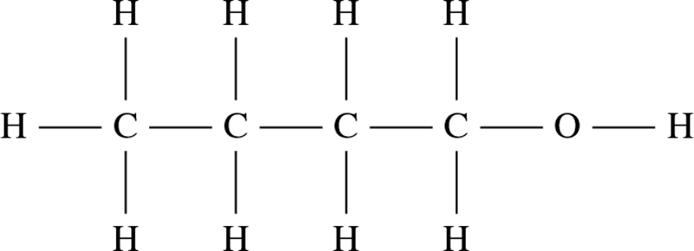 | 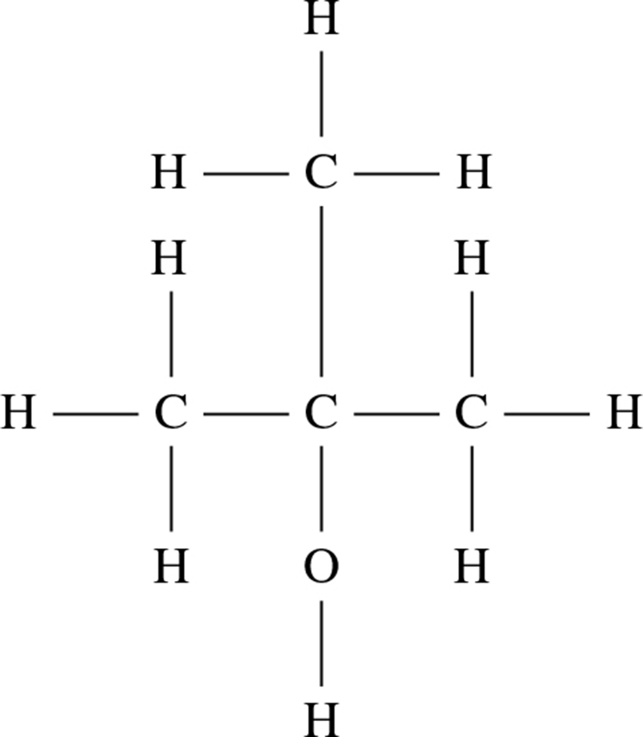
Name | butan-1-ol | 2-methyl propan-2-ol
(4 marks)
b Oxidation: CH3CH2CH2CH2OH +H2O → CH3CH2CH2COOH + 4H+ + 4e-
Reduction: MnO4– + 8H+ + 5e- → Mn2+ + 4H2O
Full equation: 4MnO4– + 12H+ + 5CH3CH2CH2CH2OH → 4Mn2+ +11H2O + 5CH3CH2CH2COOH
(4 marks)
c The primary alcohol would have the highest boiling point.*
Both alcohols have hydrogen bonding and dispersion forces between their molecules.* Although they have the same number of electrons and the same OH functional group,* the linear primary alcohol molecules can pack together more closely than the tertiary alcohol, thereby forming stronger dispersion and hydrogen bonds.*
This means that a greater amount of energy is required to break these intermolecular forces when the substance boils. (4 marks)
End of answers

